

Department of Intelligent Systems

School of Computer Science Engineering Lovely Professional University, Jalandhar December-2022

Marketing Website

REPORT BY:-

Priyam Chaudhary

Reg.No.:12223869

Roll No.:35

Section:KOC49

**Index**

1. Introduction
2. Screenshots
3. Technologies used
4. Features of project
5. Members and contribution
6. Conclusion

INDRODUCTION

Internet marketing refers to any form of advertising or marketing on the web. It’s an all-inclusive term for promotions shared via emails, social media posts, paid advertisements displayed on search engines, etc. As users get younger, companies have shifted their marketing strategies to the Internet, where they can reach a larger, more relevant audience at lower cost to traditional advertising options.

With the right online marketing strategies, small and medium businesses are finding new ways to compete against the big companies. Even with a limited budget, companies are able to get creative and effectively reach customers at each stage of the buying cycle. Be it when a consumer is searching on Google while considering a purchase or at the final stage before checkout, they will see your brand at every step of the way.

SCREENSHOTS

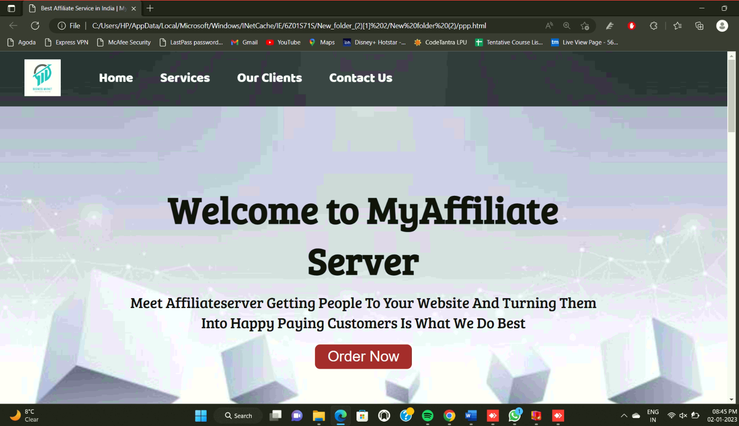

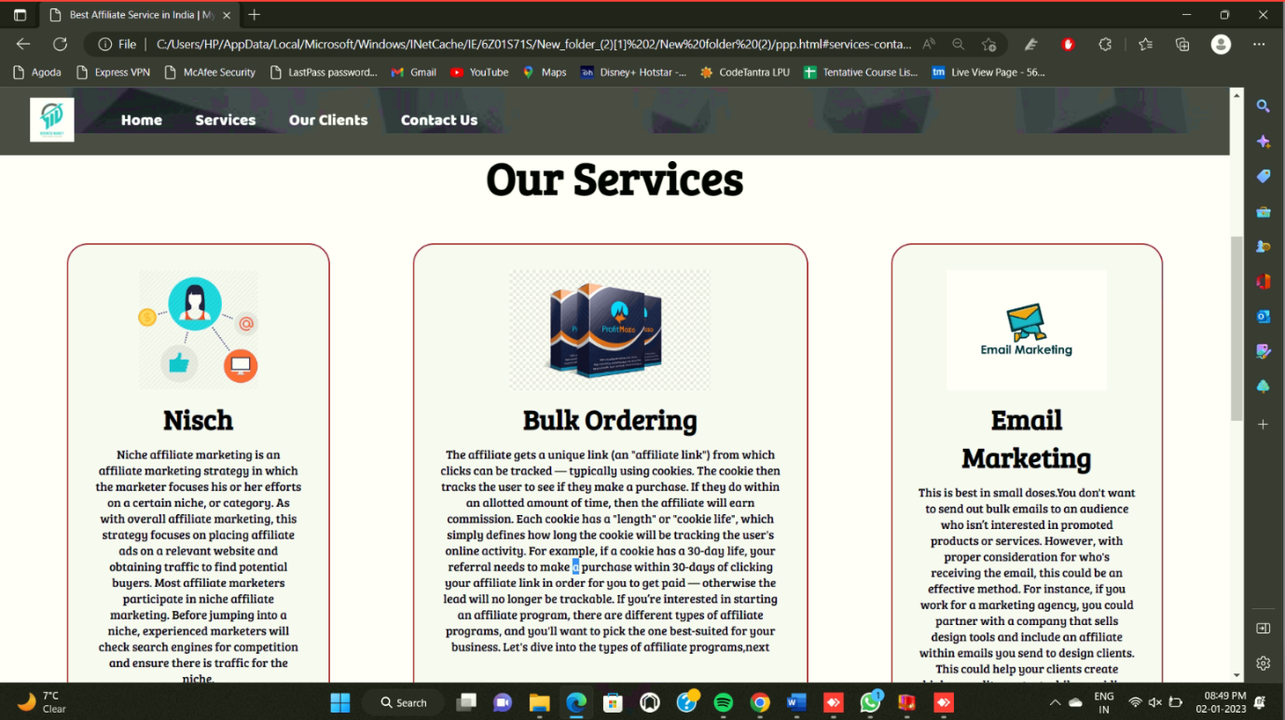

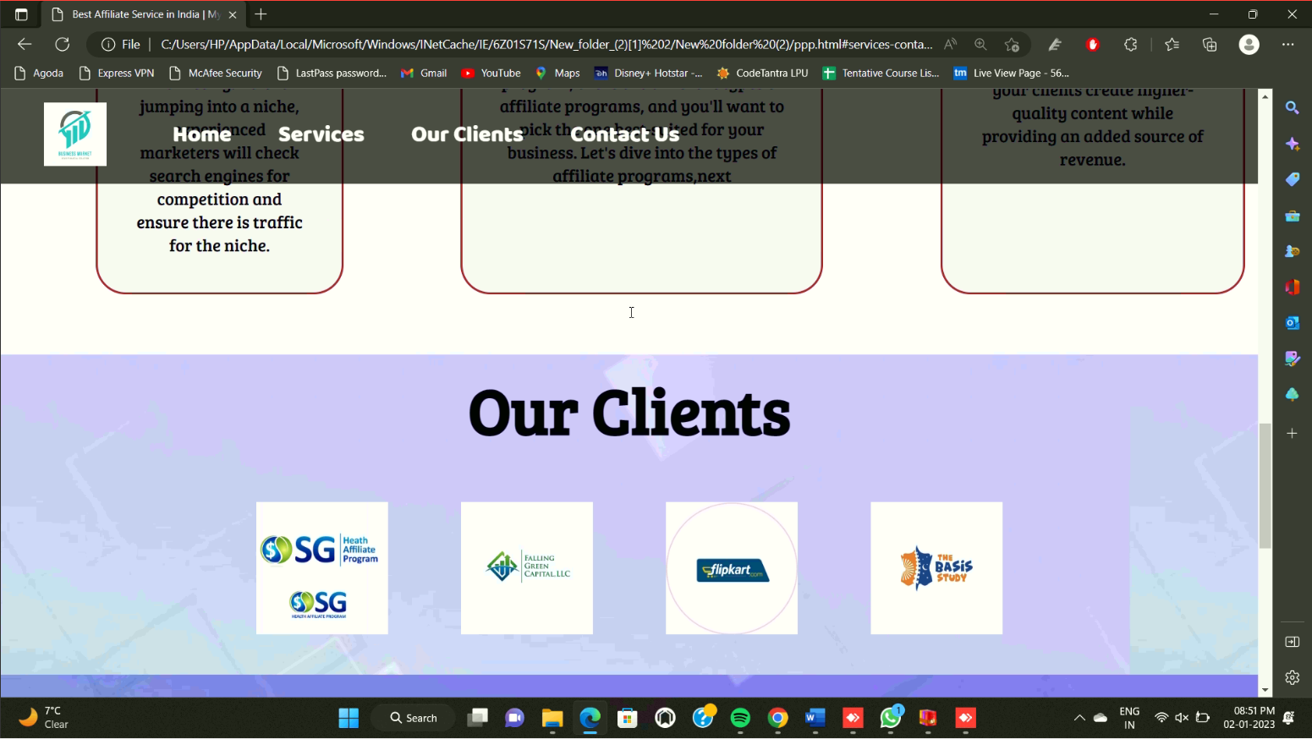

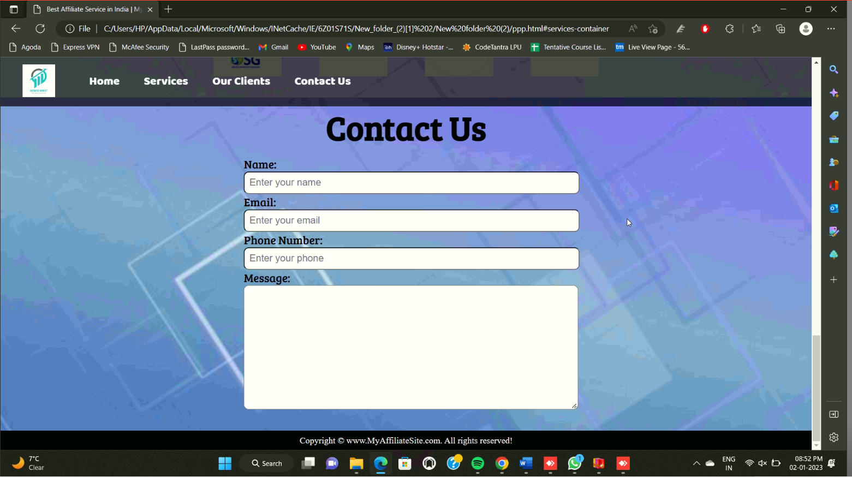

TECHNOLOGIES USED

PAGE LAYOUT HAS BEEN DESIGNED IN HTML

AND CSS HAS BEEN USED FOR ALL THE DESIGNING PART TO MAKE THIS STATIC WEBSITE.

* We have mainly used tags to add a few links to the website and images to add pictures to our website, paragraphs tags to add some content to our website and div tags to divide sections in an organized way and list tags properly to format into list.

* We have linked our CSS file to HTML using the tag href attribute.

* We also used External CSS .

We have styled our website using CSS and we have used fonts exporting it from google and have added colour for individual sections for the HTML code and have also given ample padding to make it more representative.

MEMBERS &

CONTRIBUTION

Team members:

* Alok Singh Kachchhawa

(12223802)

CONTRIBUTION:

HTML(Combined) & Images

* **Priyam Chaudhary**

**(12223869)**

**CONTRIBUTION:**

**CSS(Combined) & Content**

* Anurag Deep

(12222187)

CONTRIBUTION:

HTML & CSS(Combined)

CONCLUSION

MARKETING IS the most exciting of all business sports. It is the heartbeat of every successful business. It is continually changing in response to the explosion of information, the expansion of technology, and the aggressiveness of competition, at all levels and everywhere.

All business strategy is marketing strategy. Your ability to think clearly and well about the very best marketing strategies, and to continually change and upgrade your activities, is the key to the future of your business.

Fortunately, like all business skills, marketing can be learned by practice, experimentation, and continually making mistakes. The key is to test, test, test. And what- ever marketing strategy is working for you today, no matter how...

REFERENCES

<https://www.w3schools.com/html/>

<https://www.tutorialspoint.com/html/index.htm>

**Learning Web Design: A Beginner’s Guide to HTML, CSS, JavaScript, and Web Graphics**

**By: Jennifer Robbins’**

**End of the Report**

**Thankyou!!**